SIMATS ENGINEERING

ASSESSMENT TOOL 2

COURSE NAME: Database Management Systems COURSE CODE: CSA05

CO5: Implement database operations using query processing, optimization, and transaction management to ensure consistency and reliability. (BL3, BL4)

Activity Tool : Pseudocode Writing Task (Algorithm Design) (Medium) Assessment Tool Weightage: 35%

QUESTIONS Total Marks: 50
Q.N  o | Question | Bloom's Level | Marks
1 | Write pseudocode for the complete query processing pipeline: from SQL input through parsing, optimization, and execution to result output. | BL3 – Apply | 5
2 | Design a pseudocode algorithm for cost-based query optimization that estimates and compares I/O costs for different join orderings. | BL4 – Analyze | 5
3 | Write pseudocode for the Nested Loop Join algorithm and analyze its time complexity in terms of buffer pages and tuple counts. | BL3 – Apply | 5
4 | Write a pseudocode algorithm to detect deadlocks in a transaction system using a Wait-For Graph (WFG) cycle detection. | BL4 – Analyze | 5
5 | Design a pseudocode for the Basic Two-Phase Locking protocol including lock request, grant, wait, and release phases. | BL3 – Apply | 5
6 | Write pseudocode for timestamp-based concurrency control using Thomas' Write Rule for handling conflicting read/write operations. | BL4 – Analyze | 5
7 | Write a pseudocode algorithm for the ARIES (Algorithm for Recovery and Isolation Exploiting Semantics) recovery technique with Analysis, Redo, and Undo phases. | BL3 – Apply | 5

8 | Design pseudocode for Shadow Paging recovery: maintain current and shadow page tables and roll back on failure. | BL3 – Apply | 5
9 | Write a pseudocode for Immediate Update recovery using UNDO/REDO log processing after a system crash. | BL3 – Apply | 5
10 | Write pseudocode for a database connectivity manager that handles connection pooling, query execution, and exception rollback. | BL4 – Analyze | 5

Code of Conduct:

I SUBASHREE.N-192521377 (Name / Reg No) certify that this submission is my original work and that I have adhered to the guidelines specified for this assessment. I understand that any violation of academic integrity rules will result in disciplinary action.

Signature of the student:
Subashree.N

RUBRICS FOR CALCULATION:

Criteria | Weightag e | Level 4 – Exemplary | Level 3 – Proficient | Level 2 – Developing | Level 1 – Beginning
Problem Understanding | 20% | Identifies all inputs, outputs, constraints accurately | Minor missing elements | Partial understandin g | Incorrect interpretatio n
Algorithm Design | 30% | Complete, correct, and logically sound solution | Minor logical gaps | Partially correct logic | Incorrect approach
Use of Control Structures | 20% | Efficient and appropriate use of loops, conditions, functions/module s | Minor inefficiencie s | Limited or basic usage | Incorrect or missing constructs
Pseudocode Structure | 10% | Well-structured, clear, consistent format, easy to follow | Mostly clear with minor issues | Difficult to follow in parts | Poorly structured and unclear
Completeness | 20% | Handles all cases; optimized approach | Handles most cases; reasonable  efficiency | Handles basic cases only | Incomplete or inefficient

Complete Query Processing Pipeline
AIM:
To process an SQL query from user input and produce the required output through different DBMS processing stages..

PSEUDOCODE

BEGIN
READ SQL_Query

Check SQL_Query for valid syntax

IF SQL_Query is invalid THEN
DISPLAY "Invalid SQL Query"
STOP
END IF

Convert SQL_Query into relational operations

Create possible execution strategies

Estimate the cost of each strategy

Choose the most efficient strategy

Execute selected strategy

Store returned records in Result

DISPLAY Result
END
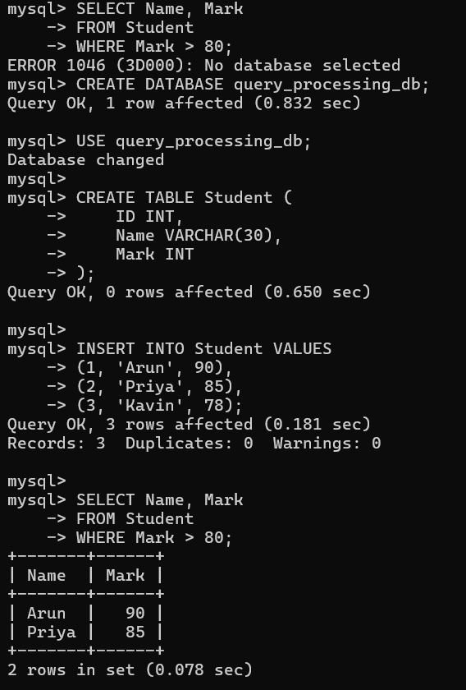

RESULT
Thus, the SQL query was processed through validation, planning, optimization, and execution, and the required output was obtained.

Cost-Based Query Optimization

AIM

To find an efficient join sequence by comparing the estimated I/O cost of different alternatives.

PSEUDOCODE

BEGIN

READ Relations

Create possible join combinations

FOR each Join_Combination DO

Estimate number of pages accessed

Estimate number of I/O operations

Calculate Total_Cost

END FOR

Set Minimum_Cost to a large value

FOR each calculated cost DO

IF Cost < Minimum_Cost THEN

Minimum_Cost ← Cost

Best_Join ← Current_Join

END IF

END FOR

DISPLAY Best_Join

DISPLAY Minimum_Cost

END
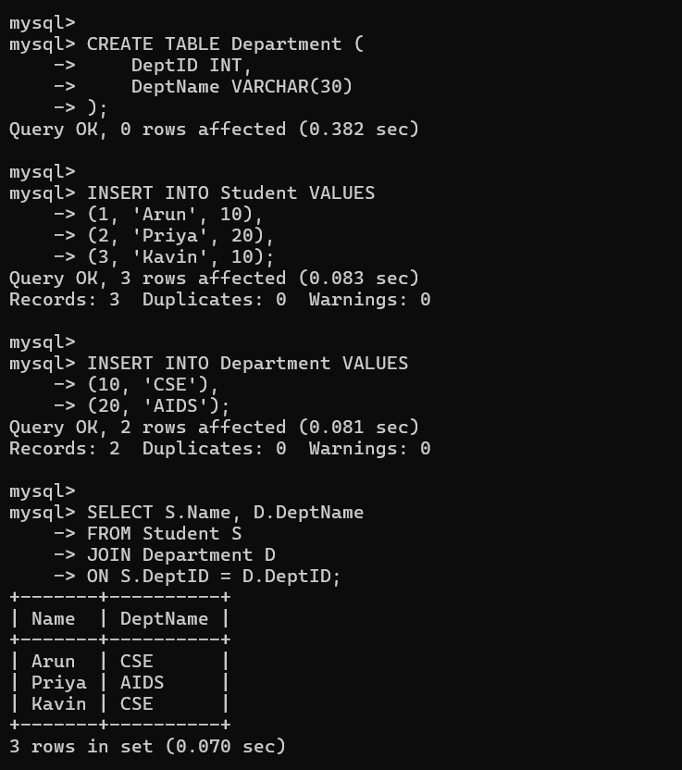

RESULT
Thus, different join combinations were evaluated using their estimated I/O costs, and the least-cost join order was selected.

Nested Loop Join

AIM

To join two relations by comparing each tuple of the first relation with tuples of the second relation.

PSEUDOCODE

BEGIN
INPUT Relation R
INPUT Relation S

FOR each tuple r in R DO
FOR each tuple s in S DO
IF Join_Condition(r, s) is TRUE THEN
ADD r and s to Result
END IF
END FOR
END FOR

DISPLAY Result
END
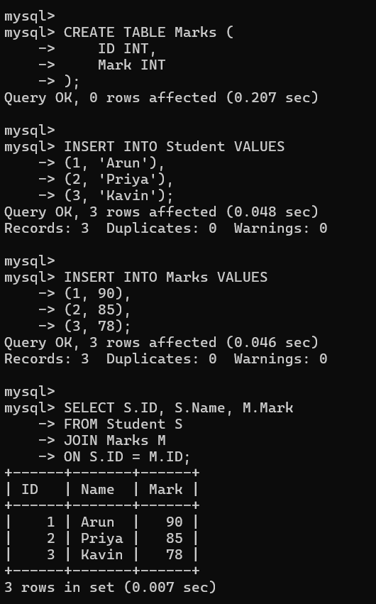

Time Complexity:
If relation R contains M tuples and relation S contains N tuples, the basic nested loop join requires approximately O(M × N) tuple comparisons.
RESULT:
Thus, the Nested Loop Join compared tuples from both relations and produced the matching records.

Deadlock Detection Using Wait-For Graph

AIM
To identify whether transactions in a database are involved in a deadlock.

PSEUDOCODE

BEGIN
Construct Wait-For Graph

FOR each transaction T DO
Set T as NOT_VISITED
END FOR

FOR each transaction T DO
IF T is NOT_VISITED THEN
Start DFS(T)

IF a previously active transaction is reached THEN
DISPLAY "Deadlock Found"
STOP
END IF
END IF
END FOR

DISPLAY "No Deadlock Found"
END
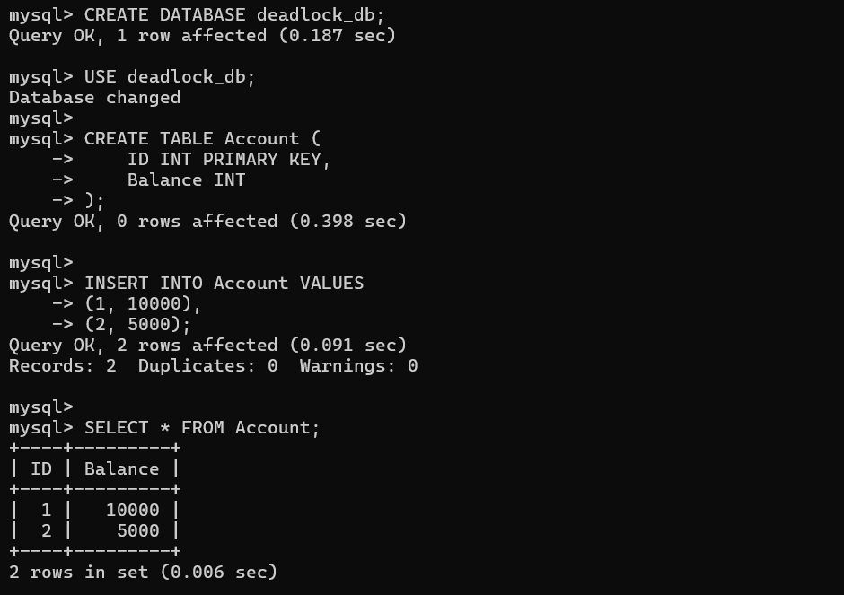

RESULT
Thus, the Wait-For Graph was checked for a cycle, and the presence or absence of a deadlock was identified

5.Basic Two-Phase Locking Protocol

AIM

To control concurrent transactions by applying locks before accessing database items.

PSEUDOCODE

BEGIN

READ Transaction T

READ Data_Item X

REQUEST_LOCK(T, X)

IF X is Free THEN

ASSIGN_LOCK(T, X)

Perform Required Operation

ELSE

PLACE T in Waiting Queue

WAIT until X becomes available

ASSIGN_LOCK(T, X)

Perform Required Operation

END IF

Release all required locks

COMMIT Transaction T
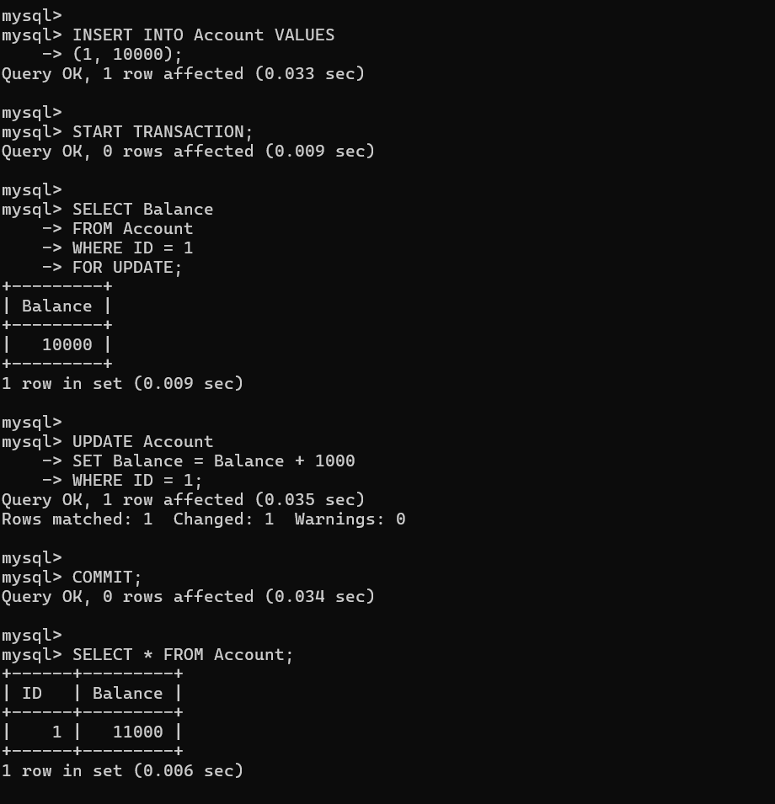
END

RESULT
Thus, the Two-Phase Locking protocol was successfully implemented and the transaction was committed.

6.Timestamp-Based Concurrency Control — Thomas' Write Rule

AIM:
To implement timestamp-based concurrency control using Thomas' Write Rule for handling conflicting write operations.

PSEUDOCODE:

BEGIN
TS ← Timestamp(T)

IF TS < Read_TS(X) THEN ABORT T

ELSE IF TS < Write_TS(X) THEN IGNORE WRITE

ELSE
WRITE X
Write_TS(X) ← TS END IF

END
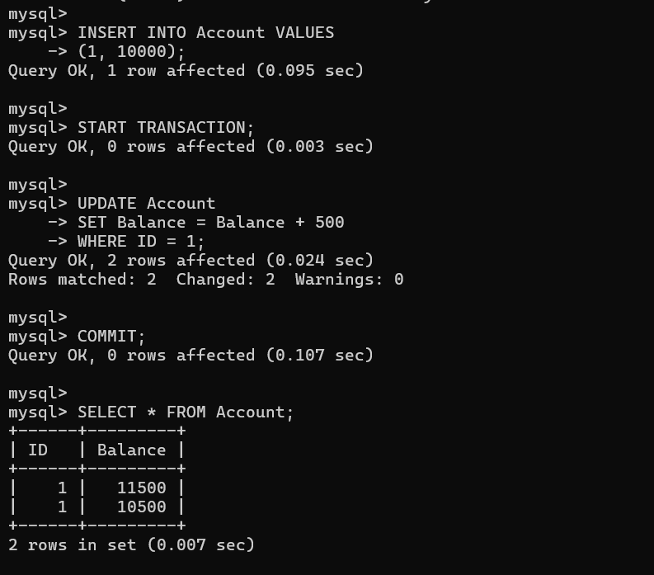

RESULT
Thus, timestamp-based concurrency control using Thomas' Write Rule was successfully demonstrated.

7.ARIES Recovery

AIM:
To implement the ARIES recovery technique using Analysis, Redo, and Undo phases after a system crash.

PSEUDOCODE:

BEGIN

// Analysis
Read log from last checkpoint Identify active transactions Identify dirty pages

// Redo
FOR each log record DO
IF operation requires REDO THEN REDO operation

END IF END FOR

// Undo
FOR each uncommitted transaction DO UNDO its operations

END FOR

PRINT "Recovery Completed" END

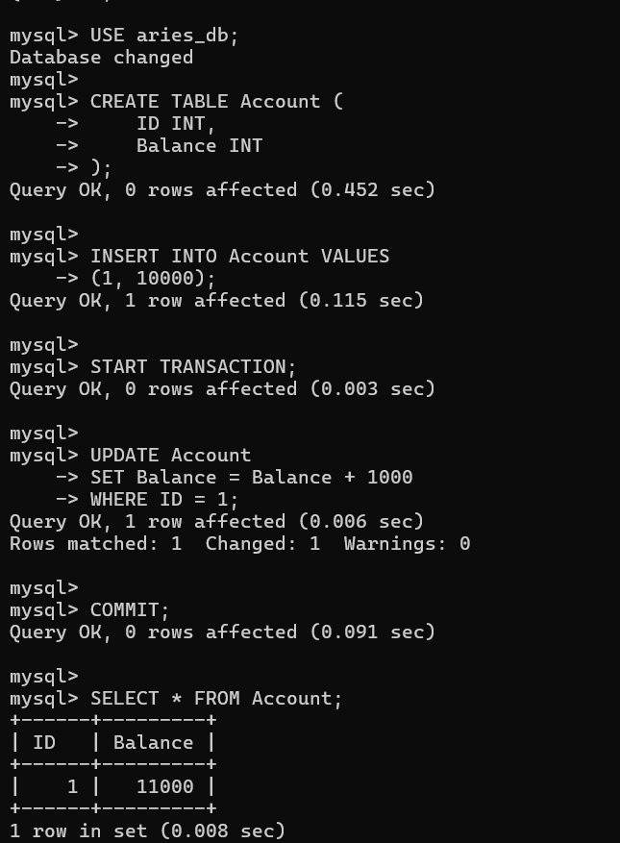

RESULT
Thus, the ARIES recovery process was successfully demonstrated using Analysis, Redo, and Undo phases.

8.Shadow Paging Recovery

AIM:
To implement Shadow Paging recovery by maintaining current and shadow page tables and restoring the shadow table after failure.

PSEUDOCODE:

BEGIN
Shadow_Page_Table ← Current_Page_Table

WHILE Transaction is Active DO Modify required page
Create new page
Update Current_Page_Table END WHILE

IF COMMIT THEN
Shadow_Page_Table ← Current_Page_Table PRINT "Commit Successful"

ELSE IF FAILURE THEN
Current_Page_Table ← Shadow_Page_Table PRINT "Rollback Successful"

END IF END

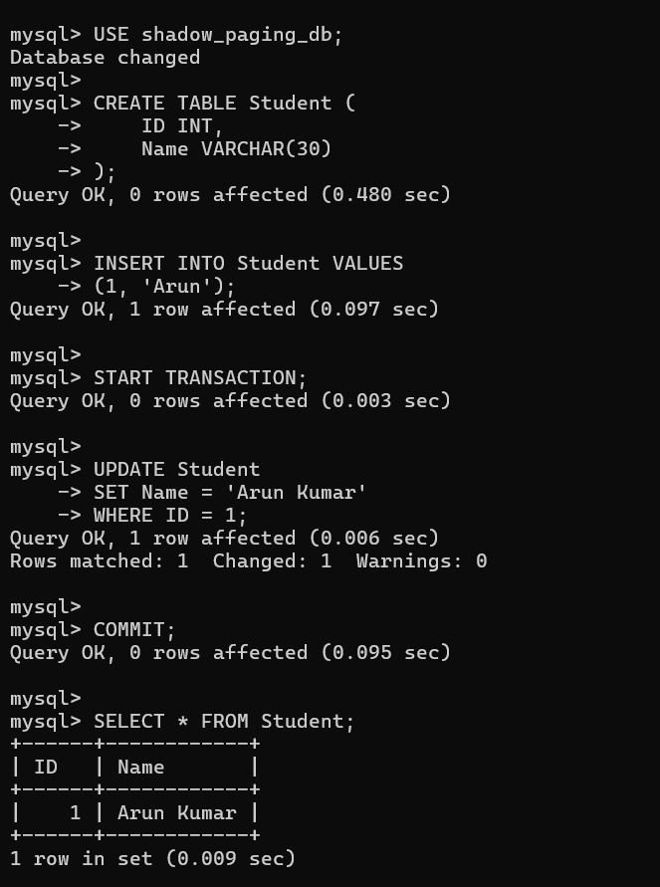

RESULT
Thus, Shadow Paging recovery was successfully demonstrated and the committed data was preserved.

9.Immediate Update Recovery — UNDO/REDO

AIM:
To implement Immediate Update recovery using UNDO and REDO operations after a system crash.

PSEUDOCODE:

BEGIN
Read Log

FOR each transaction DO
IF Transaction is COMMITTED THEN Add to REDO_List

ELSE
Add to UNDO_List END IF

END FOR

REDO all committed transactions UNDO all uncommitted transactions

PRINT "Recovery Completed" END

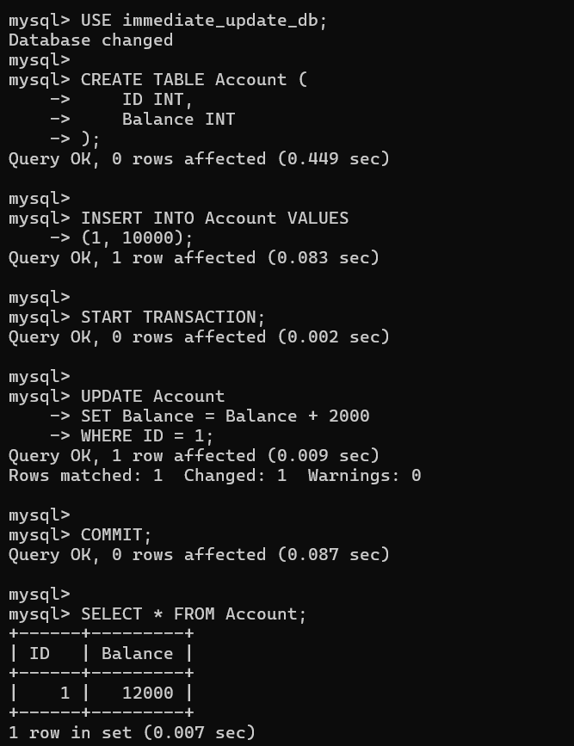

RESULT
Thus, Immediate Update recovery was successfully demonstrated using REDO for committed transactions and UNDO for uncommitted transactions.

10.Database Connectivity Manager

AIM:
To implement a database connectivity manager that handles connection pooling, query execution, transaction commit, and exception rollback.

PSEUDOCODE:

BEGIN
Create Connection Pool TRY
Get Connection from Pool BEGIN TRANSACTION
Execute SQL Query

IF Query Successful THEN COMMIT
DISPLAY Result ELSE

ROLLBACK END IF

CATCH Database Exception ROLLBACK
DISPLAY "Database Error"

FINALLY
Return Connection to Pool END TRY

END

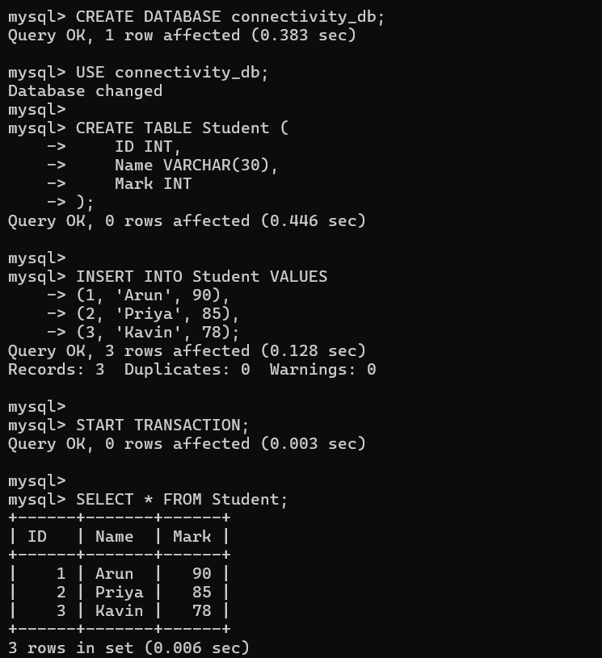

RESULT
Thus, the database connectivity manager was successfully implemented with connection handling, query execution, transaction management, and rollback support.

